Nama : Muhammad Reza Adi Wardana
Kelas : 22 RPL B
NIM : 2022010018
TUGAS 3
Hasil :
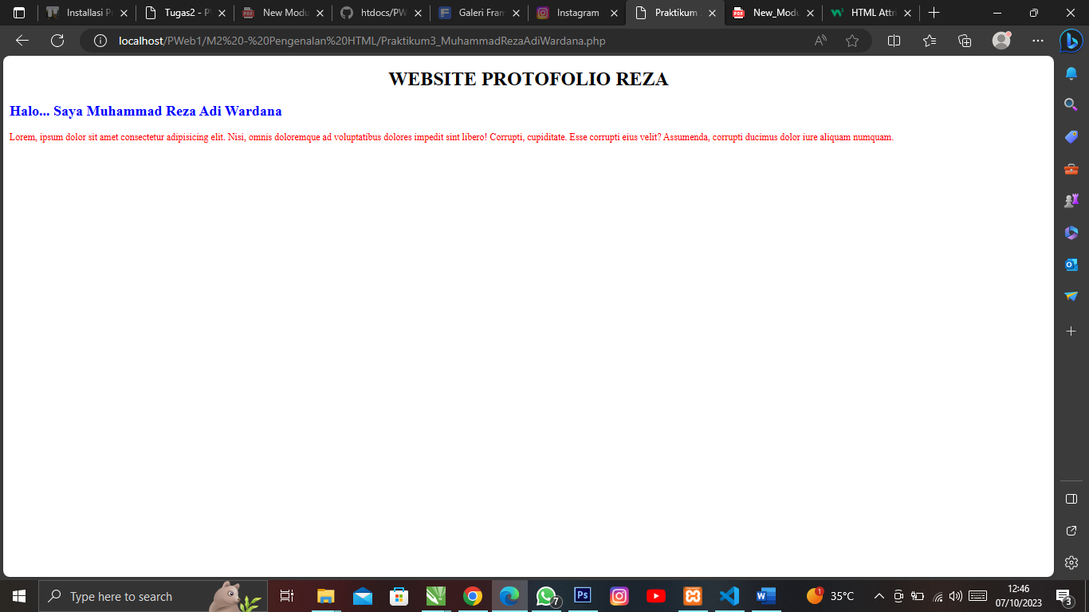

Sourcode :
<!DOCTYPE html>
<html lang="en">
<head>
<meta charset="UTF-8">
<meta name="viewport" content="width=device-width, initial-scale=1.0">
<title>Praktikum 3</title>
</head>
<body>

<h1 align="center" >WEBSITE PROTOFOLIO REZA</h1>
<h2 style="color:blue;">Halo... Saya Muhammad Reza Adi Wardana</h2>
<p style="color:red;">Lorem, ipsum dolor sit amet consectetur adipisicing elit. Nisi, omnis doloremque ad voluptatibus dolores impedit sint libero! Corrupti, cupiditate. Esse corrupti eius velit? Assumenda, corrupti ducimus dolor iure aliquam numquam.</p>

</body>
</html>

